**L. J INSTITUE OF COMPUTER APPLICATION**



**DREAM JOB**

**Internal Guide:**

Prof. Niraj Gautam

Prof. Himanshu Sharma

**Group No: - 1**

**Submitted By**

Miss. Neha Agrawal (2020004500210004)

Miss. Neha Sahu (2020004500210053)

Miss. Tisha Sadariya (2020004500210052)

Table of Contents

1. Introduction 3

1.1. Existing System 3

1.2. Need for the New System 3

1.3. Objective of the New System 3

1.4. Problem Definition 4

1.5. Core Components 4

1.6. Project Profile 4

1.7. Assumptions and Constraints 5

1.8. Advantages and Limitations of the Proposed System 5

2. Requirement Determination & Analysis 6

2.1. Requirement Determination 6

2.2. Targeted Users 6

3. System Design 7

3.1. Use Case Diagram 7

3.2. Data Dictionary 13

4. Devlopment 15

4.1. Screenshots 7

5. Agile Documentation…………………………………………………………………………………………………………………...32

5.1 Agile project Charter………………………………………………………………………….………………..…………………32

5.2Agile project plan………………………………………………………………………………………….…………………………33

5.3 Agile Test Plan………….………………………………………………………………………………………………………….…39

6. Conclusion…………………..………………………….……………………………………………………………………………………42

7. Bibliography……………………………………………..……………………………………………………………………………….…42

1. **Introduction**

* Job portal is an application which connects Job Provider and job seekers where employers are the source of the resources and the job seeker can find and apply for their targeted job. This document provides details about the entire software requirement specification for the online job portal.
* This Job Portal website is providing to the online job portal system.
* This website can be also providing information about online job.
* The customer can get the online registration.
  1. **Existing System**
* The existing system for job recruitment includes traditional methods like Employment agencies, advertising through newspapers, televisions and radios, college fairs etc., which are too slow and stressful.
* The advancement of internet, jobseekers rely on the online job portals, which makes the job search efficient. Again, most of these are limited to the web/desktop applications, which requires jobseekers to have a laptop or desktop connected to internet and is not handy.
  1. **Need for the New System**
* In comparison to the existing system the proposed system will be less time consuming and is more efficient.
* Analysis will be very easy in proposed system as it is automated
* Online Job Portal will provide the fast operation and low cost expense than old system.
* Easy job search, which is a job seeker need.
  1. **Objective of the New System**
* The objective of the web as well as android application is to provide flexibility to the jobseekers by providing the functionalities of both job search and job application in a single application.
* In addition, this application provides an effective means for the employers to post job vacancies and view the job applications by the interested applicants in a single application.
* Job Provider can also view the reviews provided by the jobseekers
  1. **Problem Definition**
* Existing system are a failing in providing quick operation
* Cost is high as well.
* Processing very lengthy and time consuming.
* More time consume for before generation.
  1. **Core Components**
* **Admin**
  + Manage Job Seeker
  + Manage Job Provider
* **Job Seeker**
* Change Password
* Update Profile
* Search Job
* Apply for job
* Upload CV
* **Job provider**
  + Change Password
  + Send Email
  + Update Profile
  + Add Job
  + Check Job Seeker Who’s apply for job
  1. **Project Profile**
* Project Title :- Dream Job
* Front End :- Django
* Back End :- MySQL
  1. **Assumptions and Constraints**
* **Assumptions**:
* In general we can assume that all the users have the knowledge about system.
* **constraints**:
* The Interface is provided only in English so, the user should know English.
* Login and Password is used for identification of user and there is no facility for guest user
* Registered user only have the rights to access the facilities provided by the system
* The user can access Dream job Management System from any computer that has internet connection and internet browsing capabilities
  1. **Advantages and Limitations of the Proposed System**
* **Advantage**
* It promotes Job Provider brand
* the time and cost to hire candidate reduces
* Combined candidate profile data become easy
* Analyzing can be done easily
* Increased Security and Privacy
* Details of the logins will be saved for the backup
* **Limitations**
* Logistical Problem
* Technology Issues
* Useful for only MCQ based questions

1. **Requirement Determination & Analysis**
   1. **Requirement Determination**

* **some of the analysis of our system**
* **Security:**

only authorized people can make changes in database

* **Maintability:**

If any occur in the system it can be easily maintained

* **Reusability:**

This project is reusable by any institute.

* 1. **Targeted Users**
* Admin
* Job Seeker
* Job provider

1. **System Design**
   1. **Use case Diagram**

* **Admin**



* **Job Seeker and job Provider**



**3.2** **Data Dictionary**

1. **SeekerUser**

|  |  |  |  |  |
| --- | --- | --- | --- | --- |
| **Sr_no** | **Field** | **data type** | **constraint** | **Description** |
| 1 | Id | int(4) | Primary key | Jobseeker Id |
| 2 | first_name | varchar(15) | Not Null | Jobseeker First Name |
| 3 | last_name | varchar(15) | Not Null | Jobseeker Last Name |
| 3 | email_id | varchar(40) | Not Null | Jobseeker Email id |
| 4 | password | varchar(15) | Not Null | Jobseeker Password |
| 5 | conform_password | varchar(15) | Not Null | Jobseeker conform Password |
| 6 | Mobile | int(11) | Not Null | Jobseeker Contact No |
| 7 | image | varchar(20) | Not Null | Jobseeker Image |
| 8 | gender | varchar(10) | Not Null | Jobseeker Gender |

1. **Provider**

|  |  |  |  |  |
| --- | --- | --- | --- | --- |
| **Sr_no** | **Field** | **data type** | **constraint** | **Description** |
| 1 | Id | int(4) | Primary key | Provider Id |
| 2 | first_name | varchar(15) | Not Null | Provider First Name |
| 3 | last_name | varchar(15) | Not Null | Provider Last Name |
| 3 | email_id | varchar(40) | Not Null | Provider Email id |
| 4 | password | varchar(15) | Not Null | Provider Password |
| 5 | conform_password | varchar(15) | Not Null | Provider conform Password |
| 6 | mobile | int(11) | Not Null | Provider Contact No |
| 7 | image | varchar(20) | Not Null | Provider Image |
| 8 | gender | varchar(10) | Not Null | Provider Gender |
| 9 | company | varchar(100) | Not Null | Provider Company Name |

1. **Job**

|  |  |  |  |  |
| --- | --- | --- | --- | --- |
| **Sr_no** | **Field** | **data type** | **constraint** | **Description** |
| 1 | id | int(4) | Foreign Key | Provider id |
| 2 | title | varchar(100) | Not Null | Job Title |
| 3 | salary | float(10) | Not Null | Job Salary |
| 4 | description | varchar (300) | Not Null | Job Description |
| 5 | experience | varchar (50) | Not Null | Experience |
| 6 | location | varchar (100) | Not Null | Location |
| 7 | skills | varchar (100) | Not Null | Skills |

1. **Apply**

|  |  |  |  |  |
| --- | --- | --- | --- | --- |
| **Sr_no** | **Field** | **data type** | **constraint** | **Description** |
| 1 | id | int(4) | Foreign Key | Job |
| 2 | id | int(4) | Foreign Key | SeekerUser |
| 3 | resume | varchar(50) | Not Null | Seeker Resume |
| 4 | applydate | date | Not Null | Apply Date |

1. **ContactUs**

|  |  |  |  |  |
| --- | --- | --- | --- | --- |
| **Sr_no** | **Field** | **data type** | **constraint** | **Description** |
| 1 | id | int(4) | Primary Key | Contact Us |
| 2 | first_name | varchar(50) | Not Null | First Name |
| 3 | last_name | varchar(50) | Not Null | Last Name |
| 4 | mobile | int(11) | Not Null | Phone Number |
| 5 | message | varchar(100) | Not Null | Message |

1. **Question**

|  |  |  |  |  |
| --- | --- | --- | --- | --- |
| **Sr_no** | **Field** | **data type** | **constraint** | **Description** |
| 1 | id | int(4) | Foreign Key | Provider |
| 2 | title | varchar(100) | Not Null | Question Topic Title |
| 3 | question | varchar(100) | Not Null | Question List |

1. **Development**
   1. **Screenshots**
2. **Home Page**

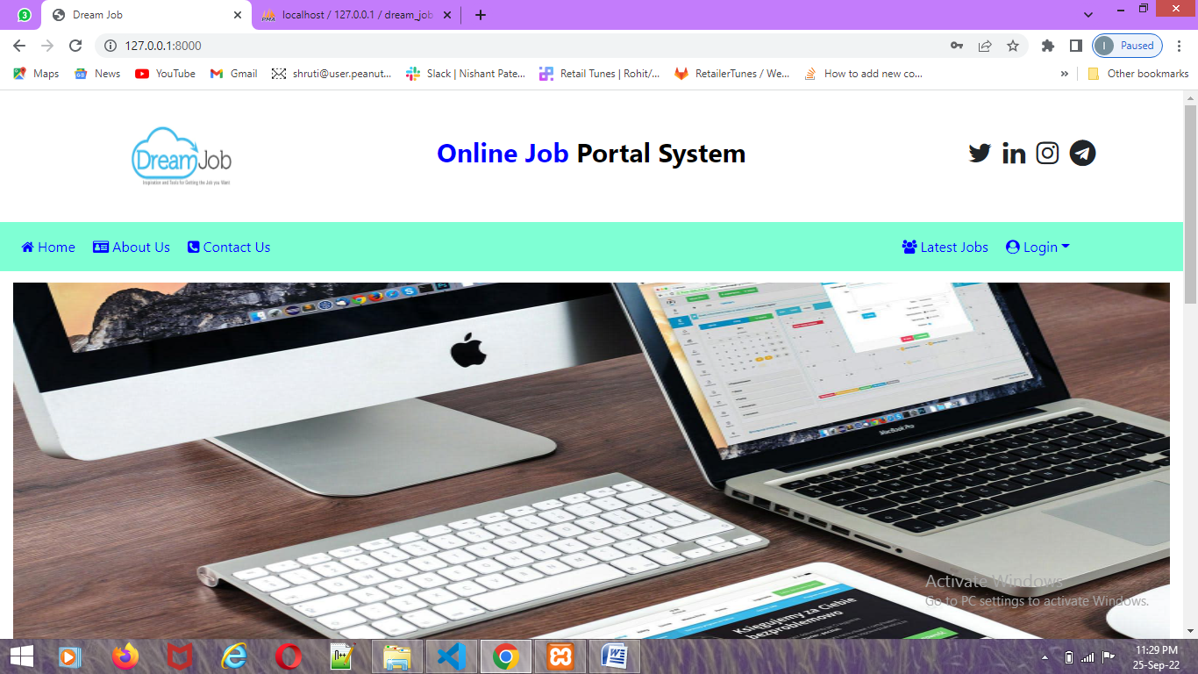

1. **User Login**

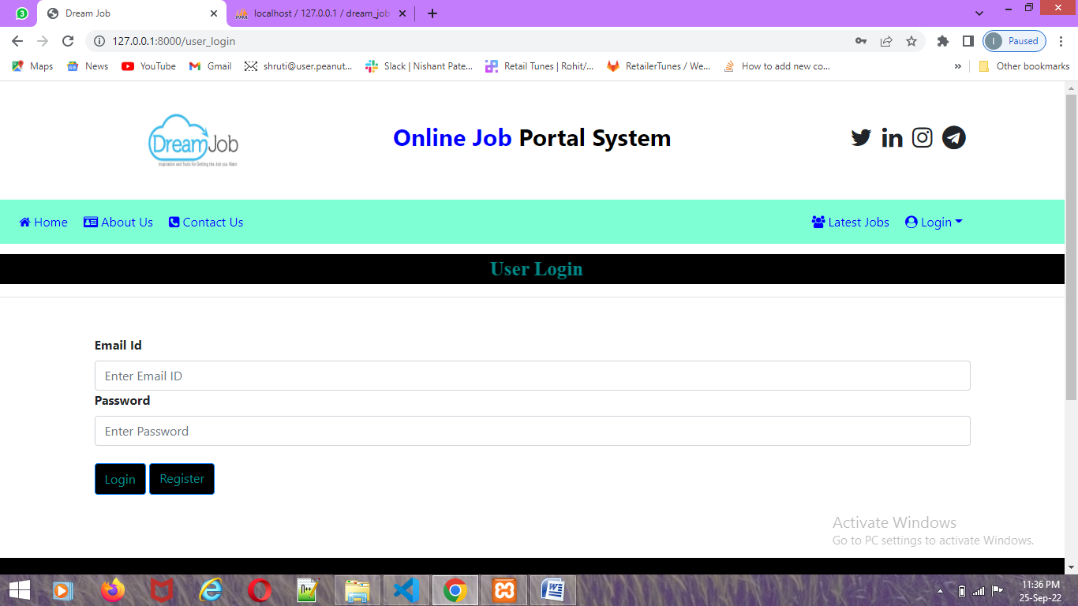

1. **User Registration**

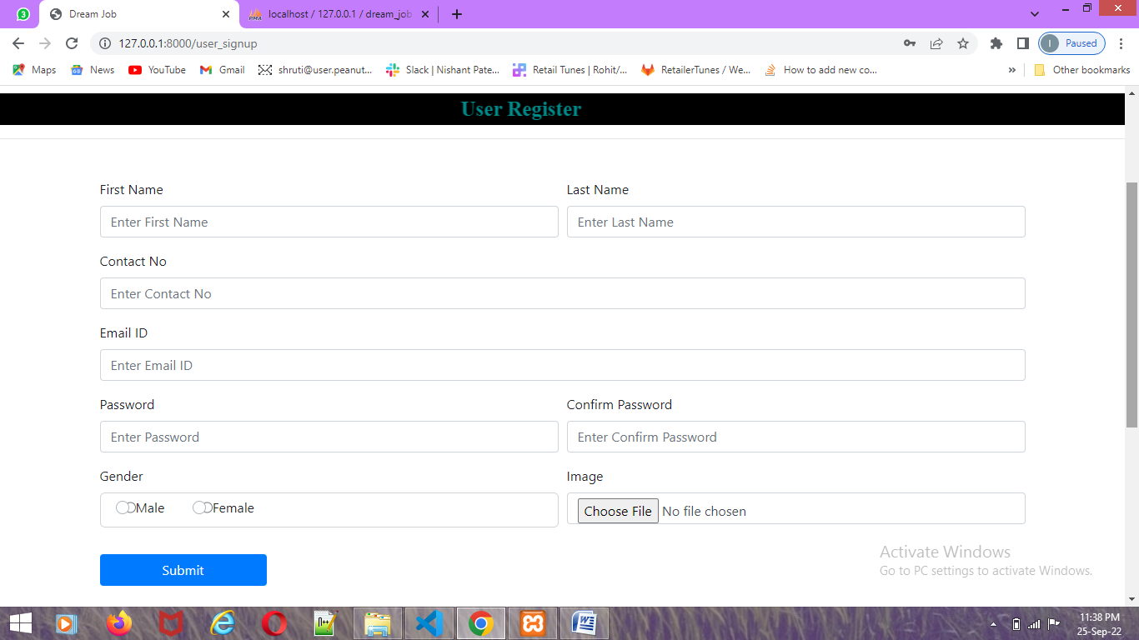

1. **User Profile Update**

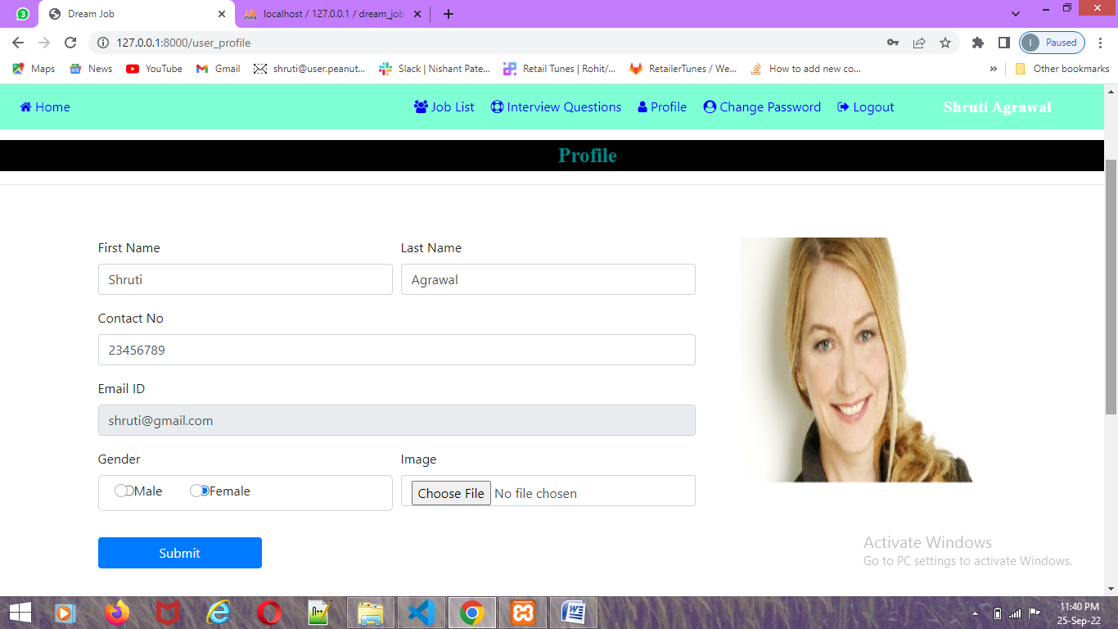

1. **View Latest Job**

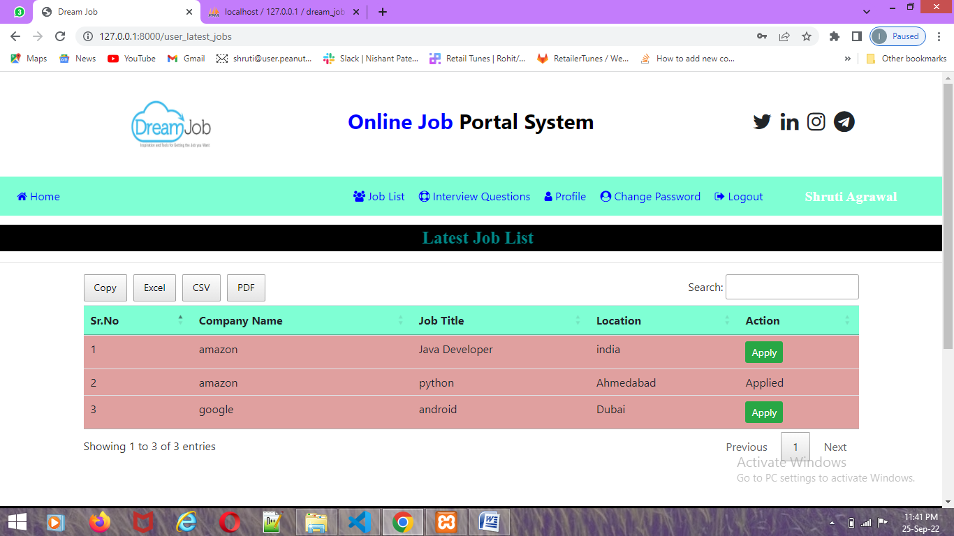

1. **Apply For Job**

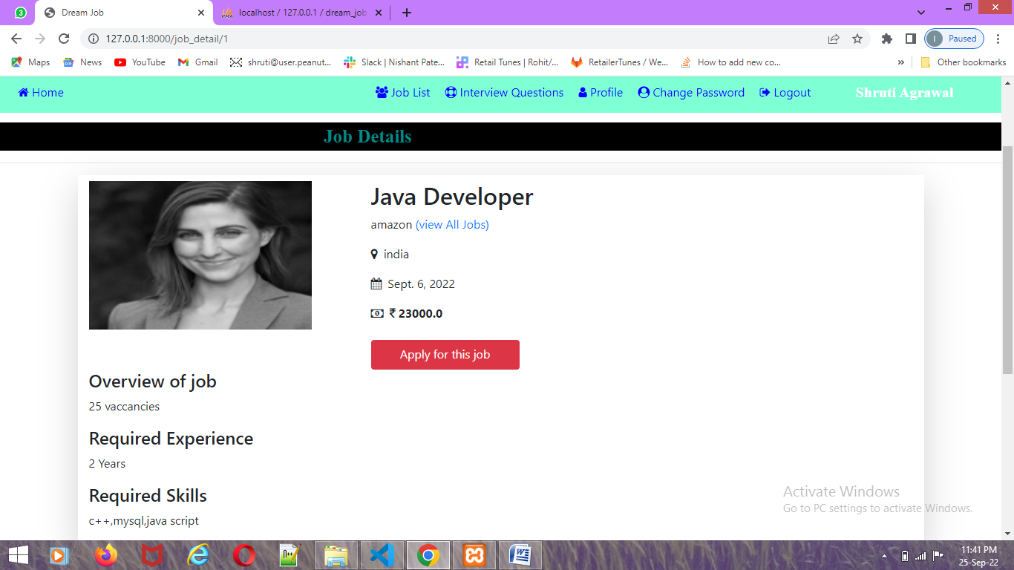

1. **Upload Resume**

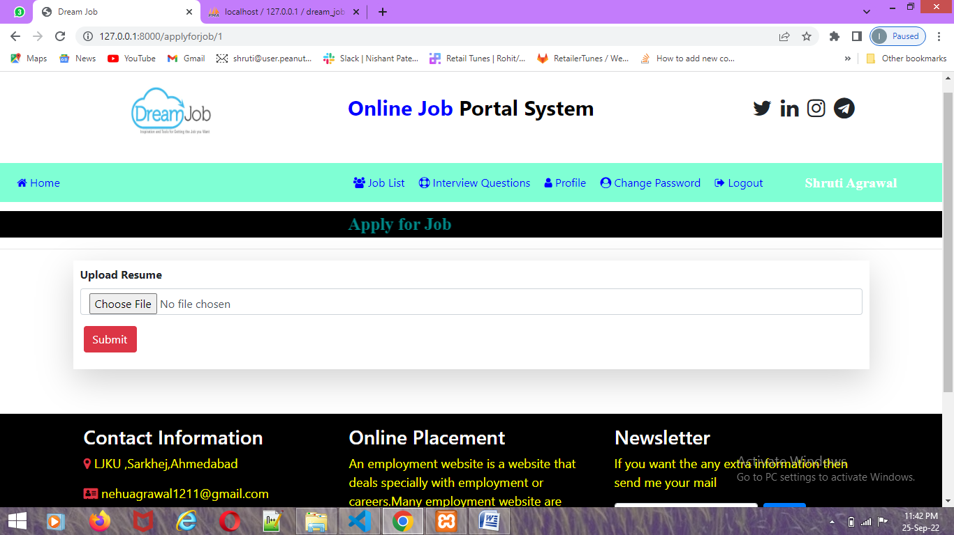

1. **Change Password**

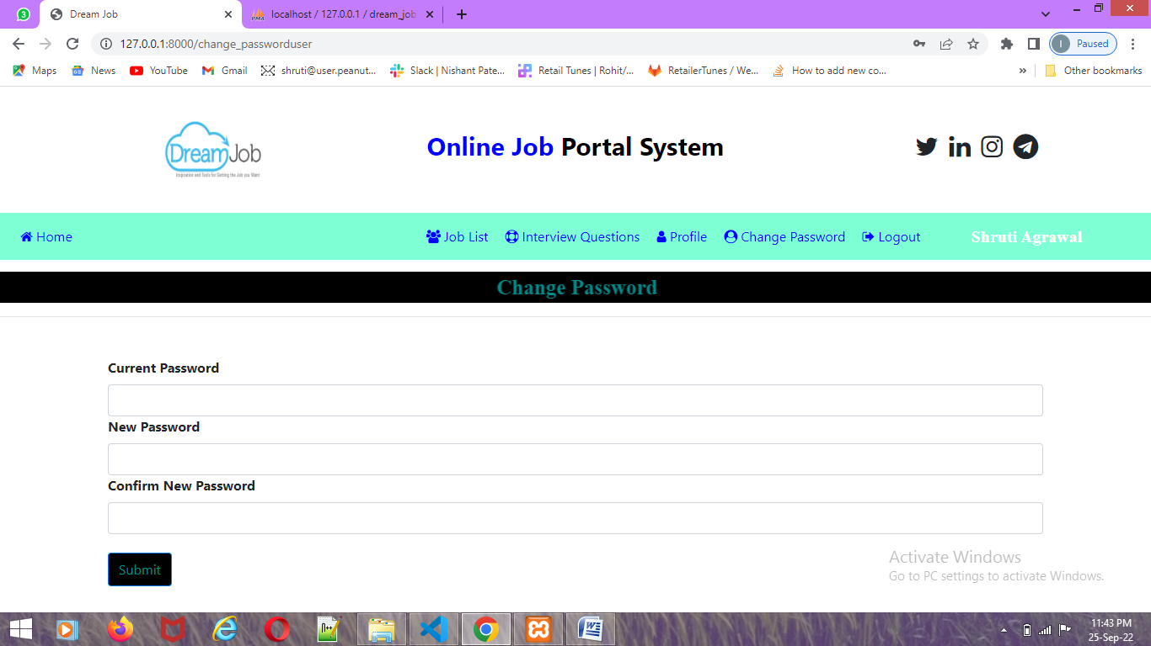

1. **View Job Related Question Answer**

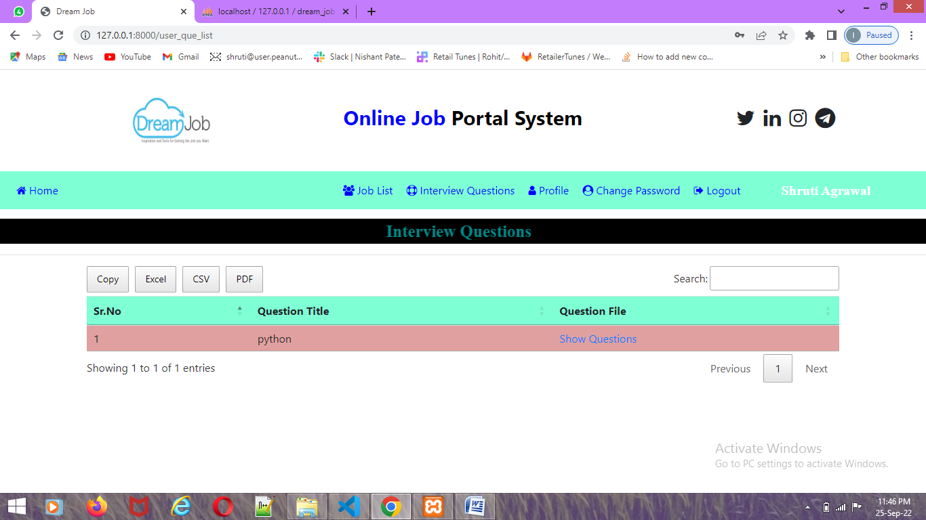

1. **Provider Login**

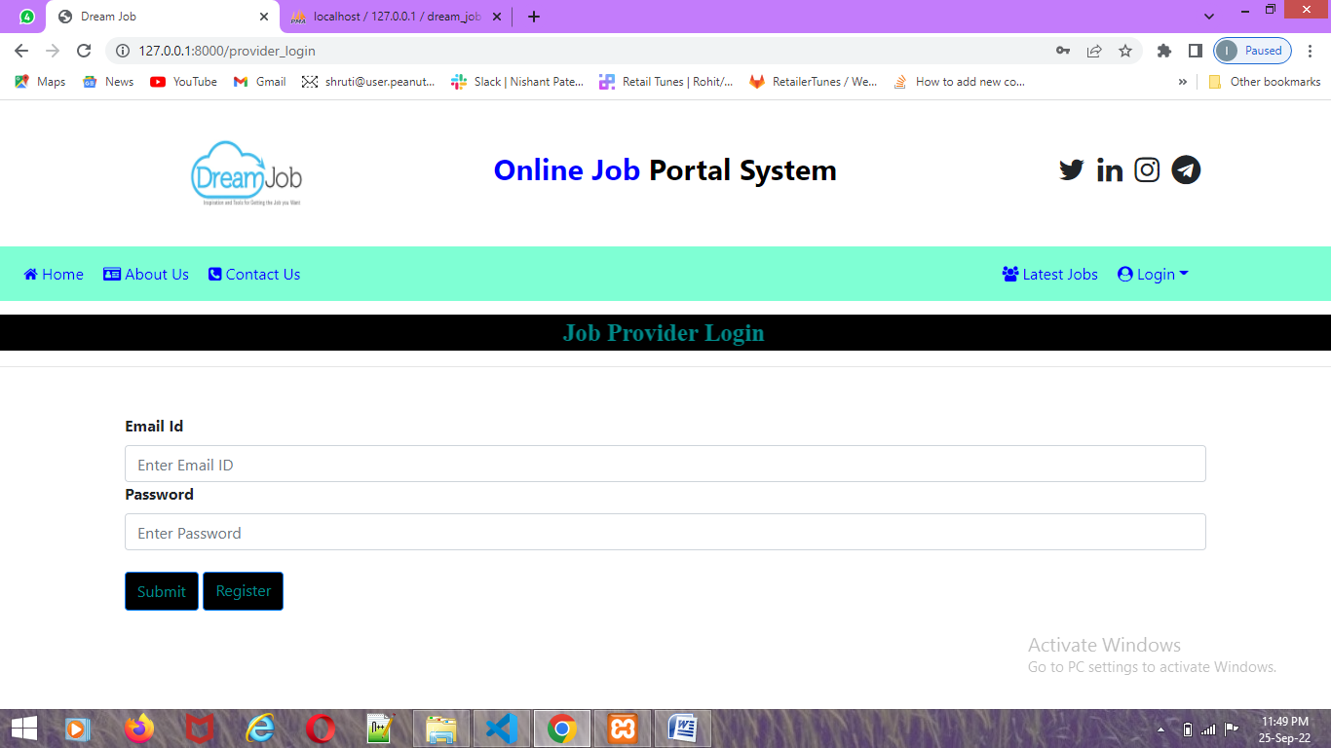

1. **Provider Registration**

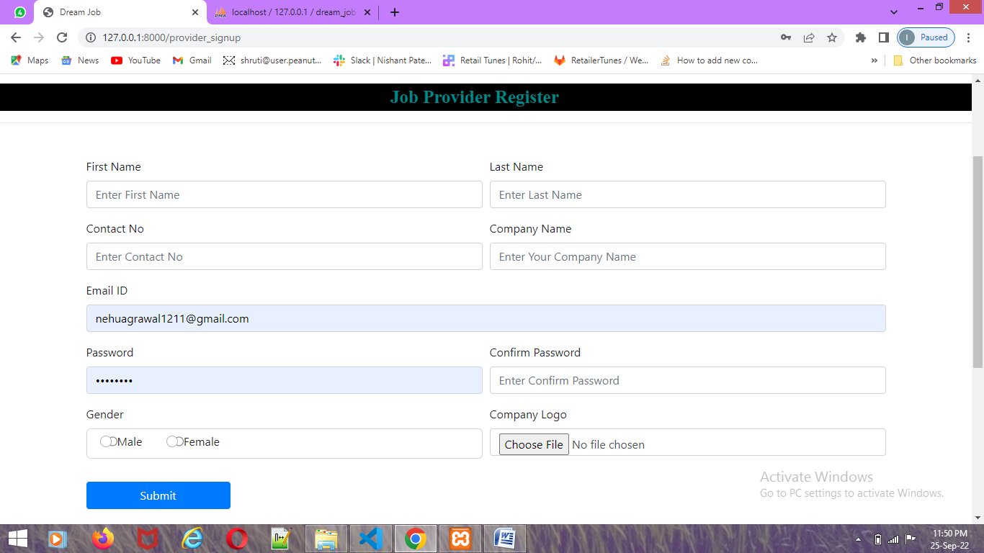

1. **Add Job Post**

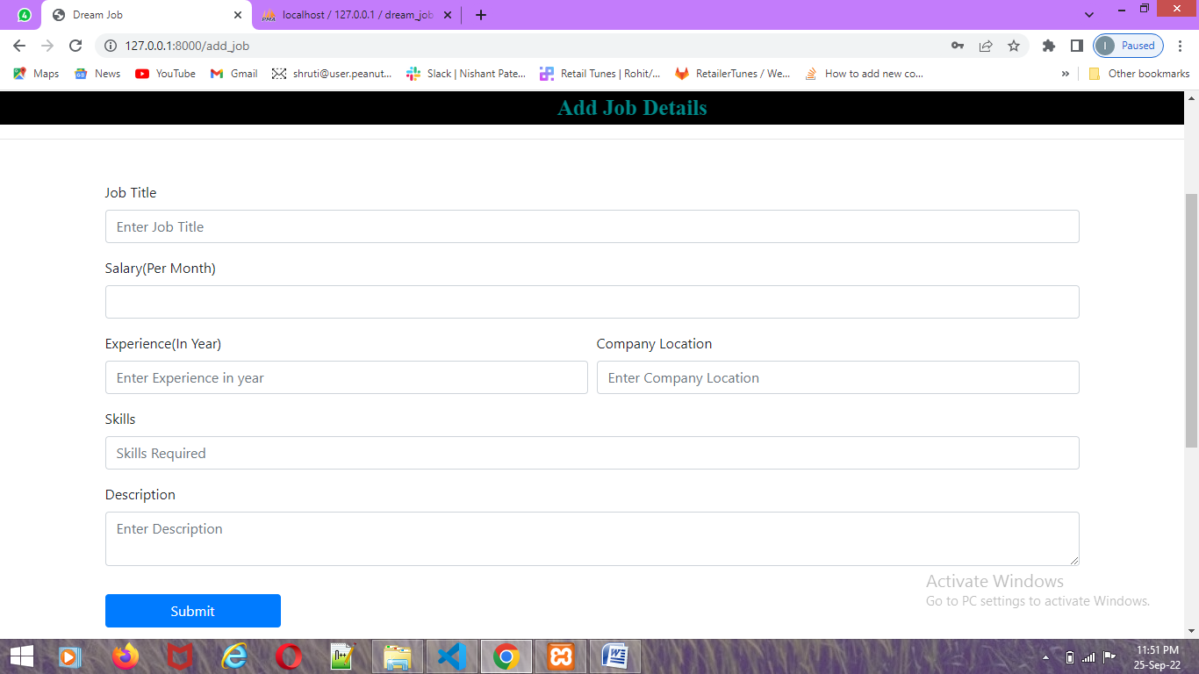

1. **View Job Posted**

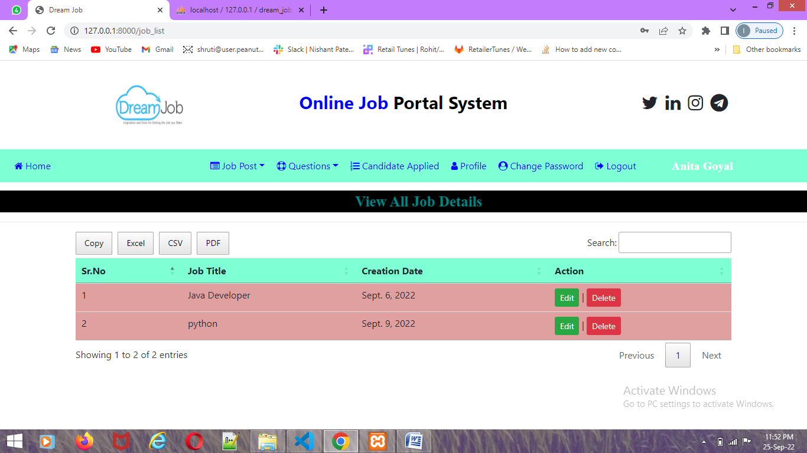

1. **Add Question**

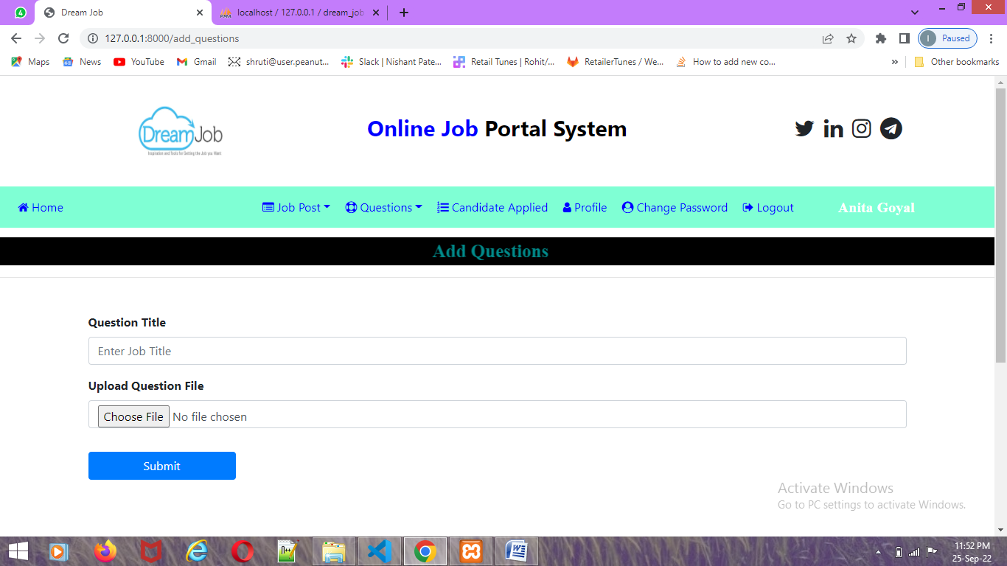

1. **View Question**

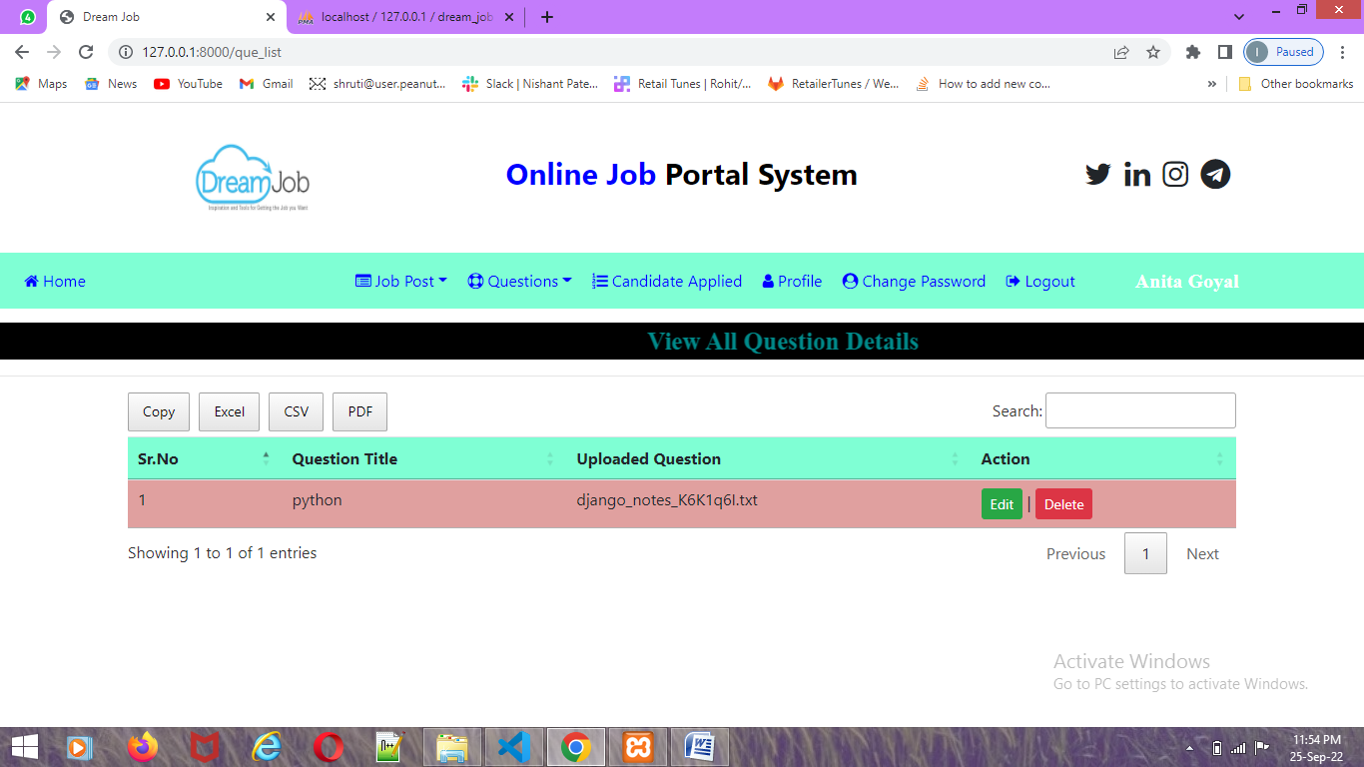

1. **Applied Candidate**

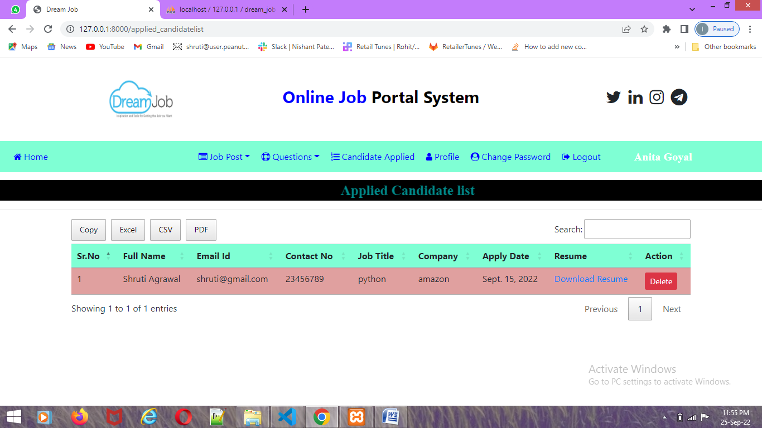

1. **Profile Update**

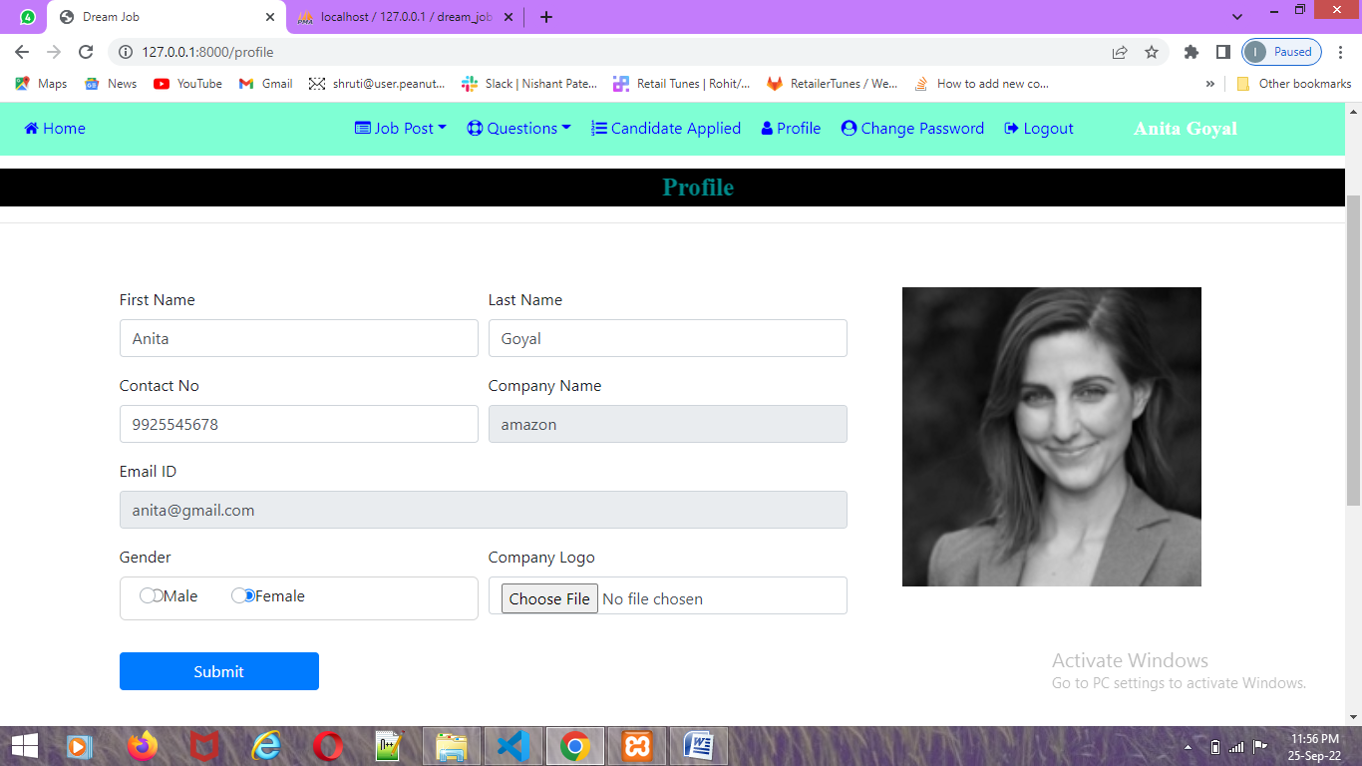

1. **Change Password**

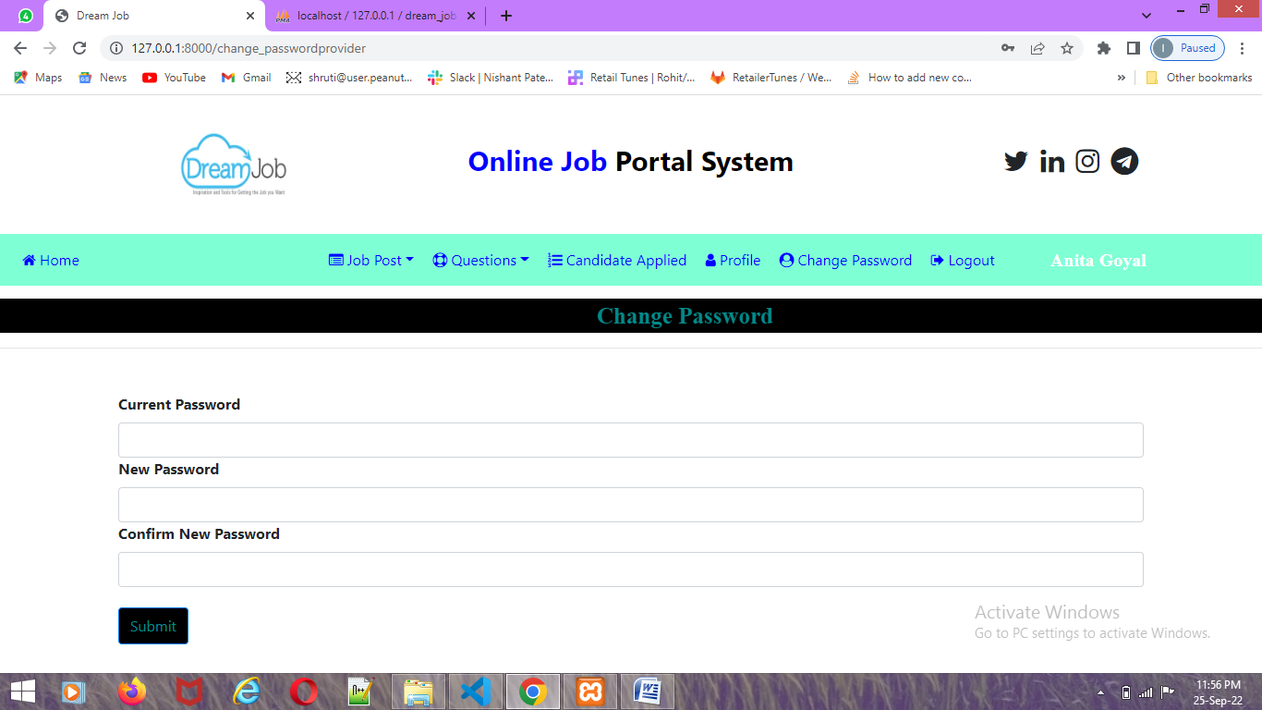

1. **Admin Login**

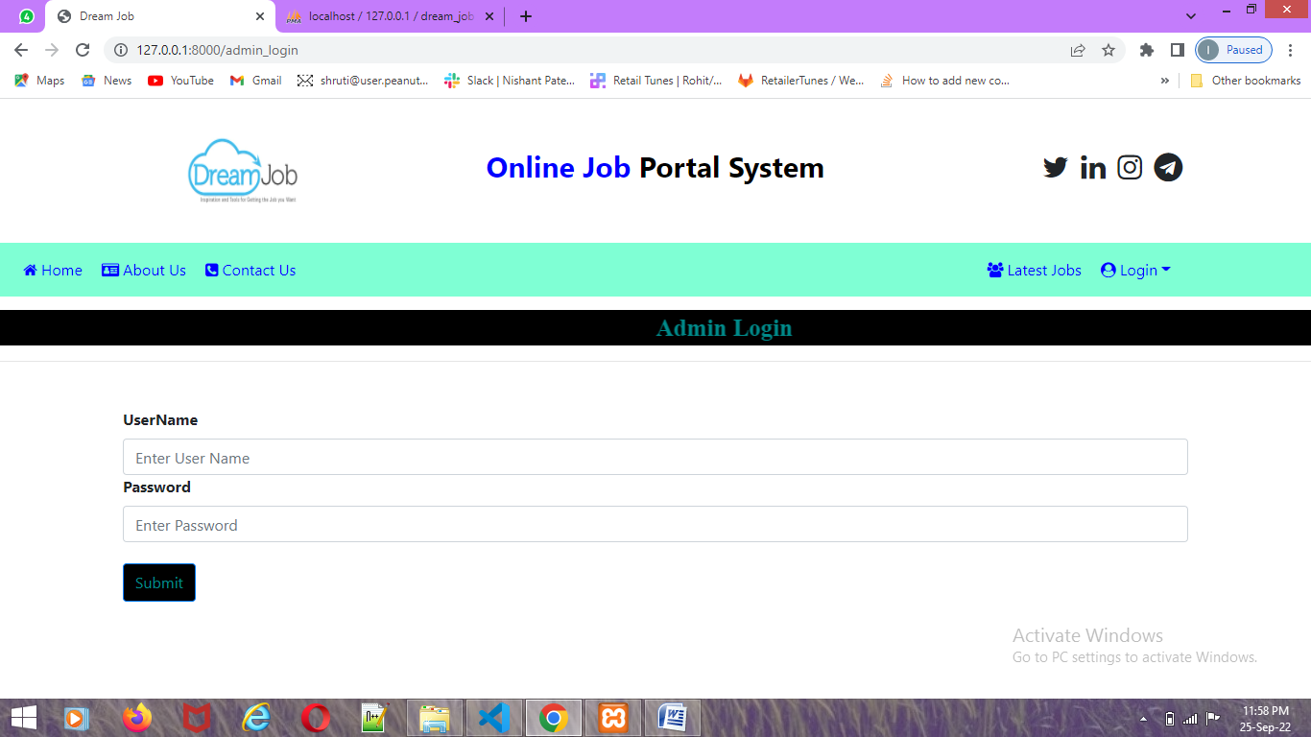

1. **Admin Home Page**

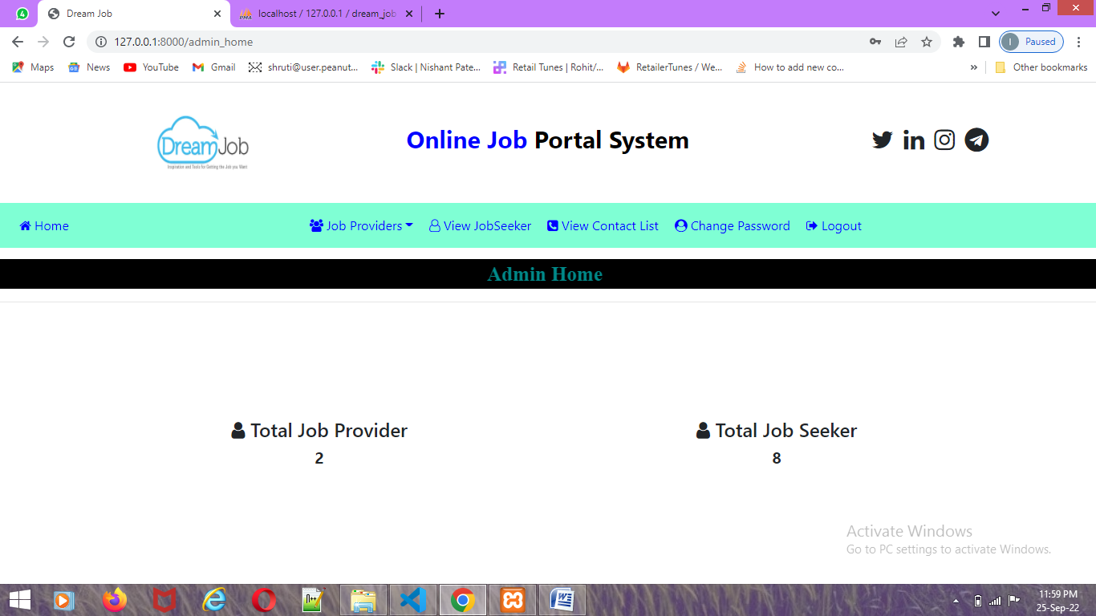

1. **View Provider**

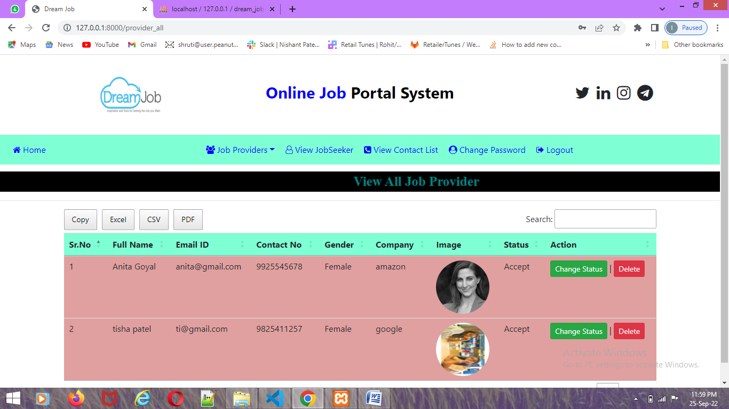

1. **Change Provider Status**

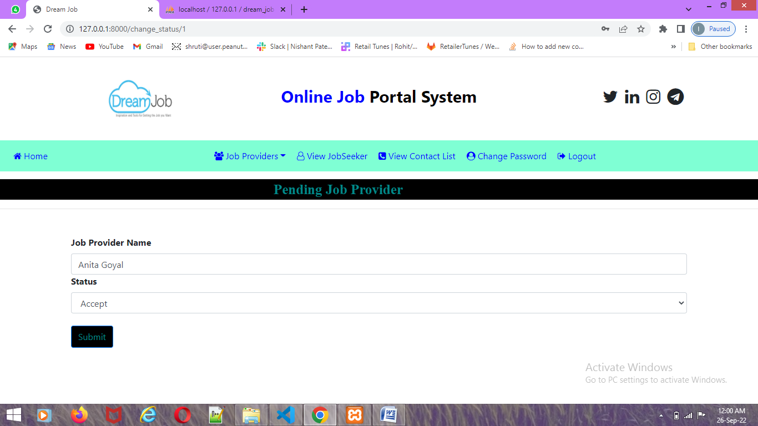

1. **View Seeker**

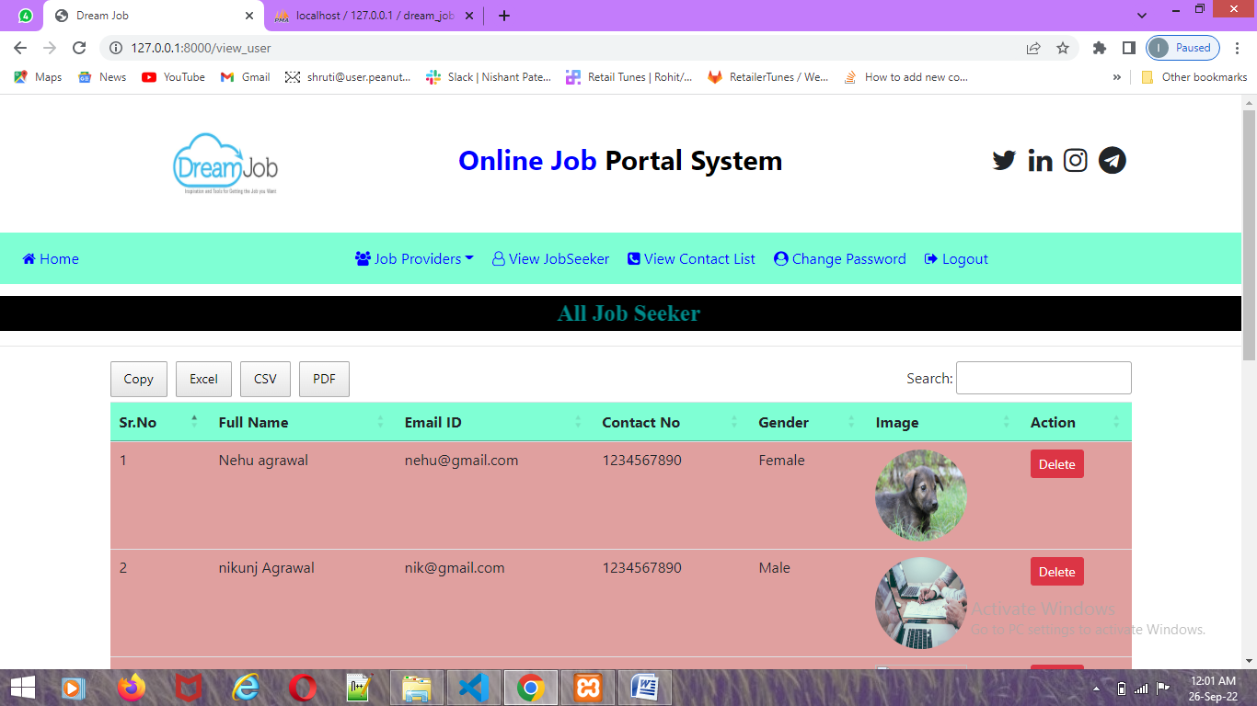

1. **View Contact List**

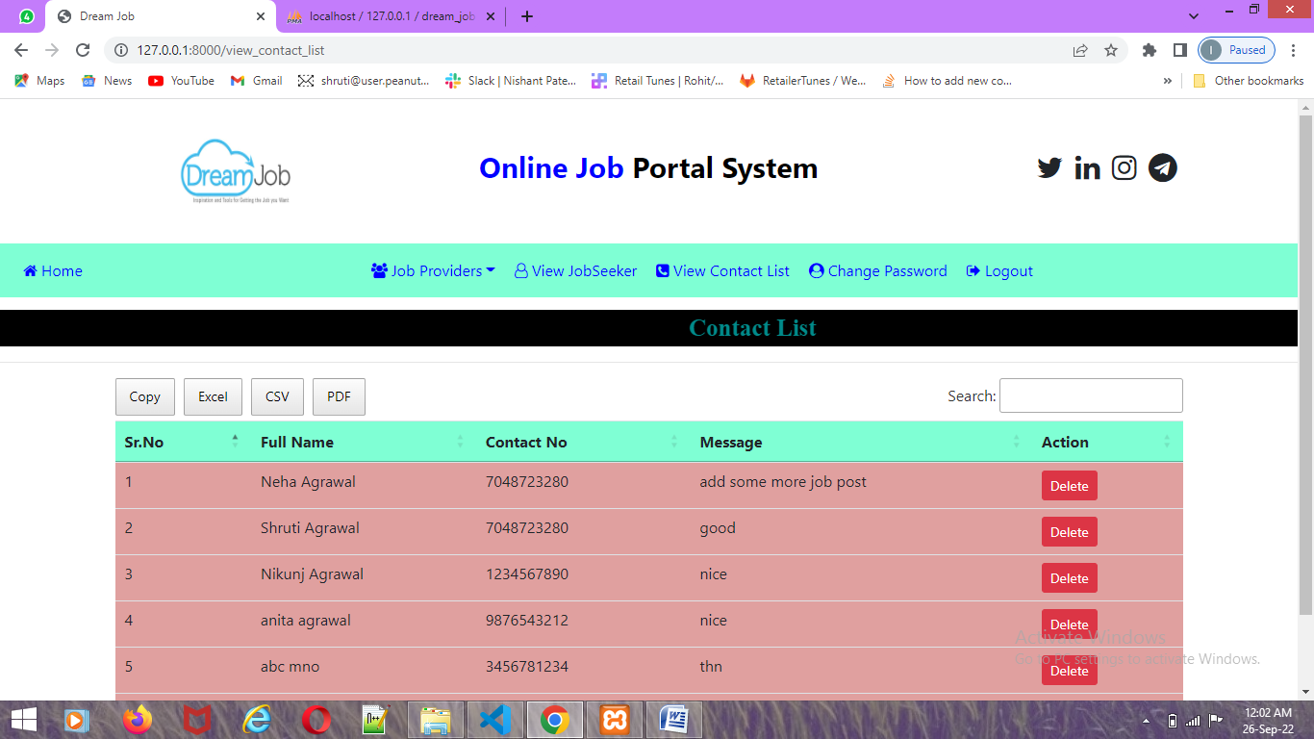

1. **About Us**

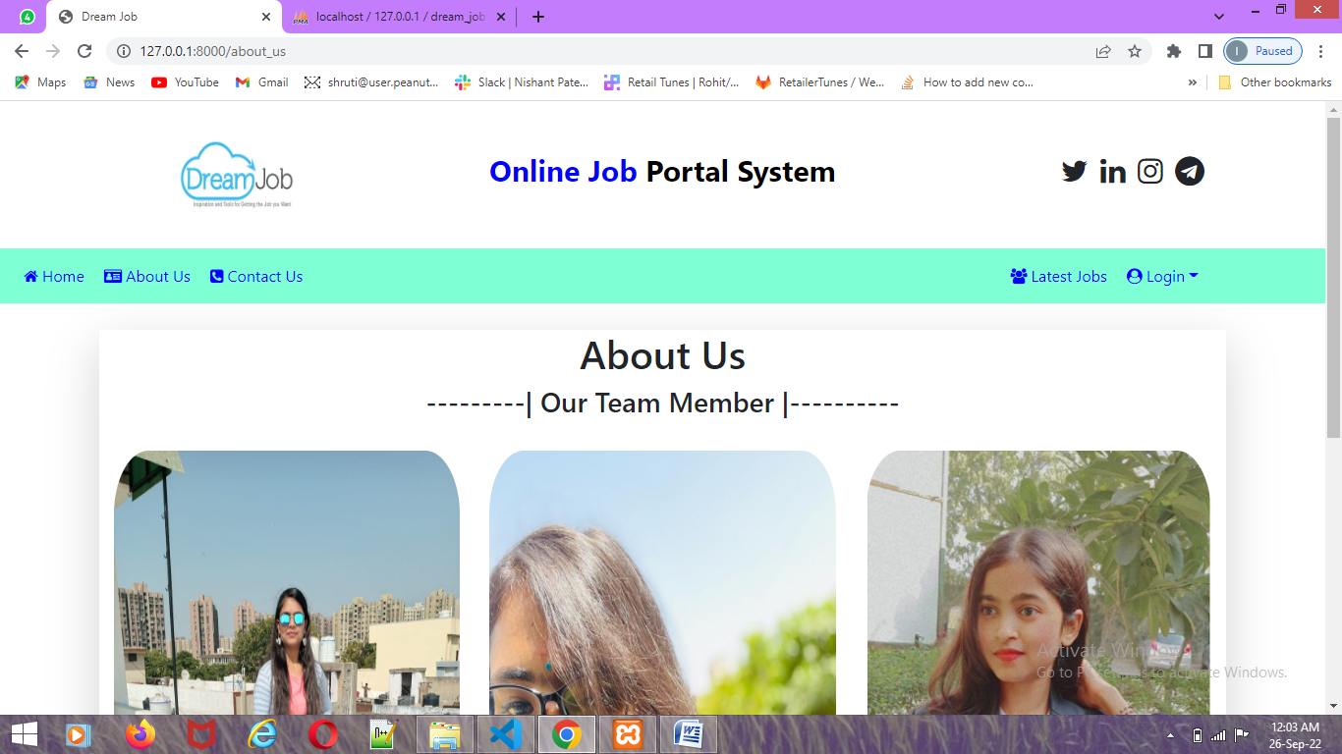

1. **Contact Us**

